Transportation Panel

Alabama

John R. Cooper, Transportation Director
John R. Cooper came out of retirement to serve as Alabama’s Transportation Director effective January 17, 2011. From 2002 to 2008, John was Chief Executive Officer of Avocent Corporation in Huntsville, a global provider of information technology infrastructure management; he was chairman of Avocent from 2003 to 2008.
John has a business background that has seen him serve as a CEO, CFO, Corporate Vice President and as a partner in large accounting firms. He holds bachelor's and master's degrees in accounting from the University of Alabama.

Edward N. Austin, Chief Engineer
Edward Austin was appointed Chief Engineer for ALDOT on October 1, 2020, by the Transportation Director and Governor.
Edward began working with ALDOT in 1991 after graduating from Auburn University with a Bachelor of Civil Engineering degree. Edward is a Registered Professional Engineer in the State of Alabama.

Arkansas


Chief Engineer for Preconstruction – Jessie Jones
Jessie Jones holds a bachelor’s degree in civil engineering from Arkansas State University in Jonesboro and a master’s degree in civil engineering from the University of Arkansas at Fayetteville. She has been a Registered Professional Engineer in the state of Arkansas since 2005.
Jessie began her career with the Arkansas Department of Transportation (ARDOT) as a Civil Engineer in the Bridge Division in January 2002. She followed the engineering career path and has served in various positions within the agency. She was appointed Chief Engineer for Preconstruction in January 2025.
Jessie is a member of multiple state and national engineering and transportation committees and organizations.
Jessie is an avid hiker and can often be found with her camera exploring and capturing the many beautiful and scenic locations within the state of Arkansas.

Louisiana
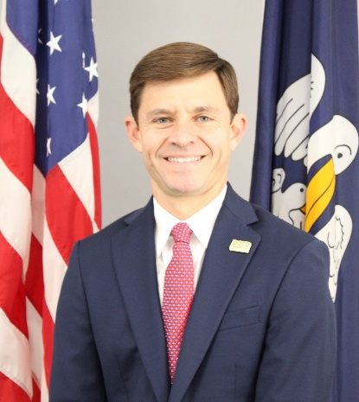

Glenn Ledet, Jr., Secretary

Secretary Glenn Ledet has extensive experience in both the public and private sectors building public infrastructure across the Gulf Coast. Most recently, Mr. Ledet spent the last 1.5 years serving as the Executive Director of the Louisiana Coastal Protection and Restoration Authority, leading the agency’s implementation of the state’s $50 billion Coastal Master Plan.

Mr. Ledet also has an extensive engineering and business background serving for over 13 years in the engineering industry, including multiple years in management positions with nationally renowned engineering, planning, and construction management firms, where he led strategic growth, business development, and operations efforts.

Mr. Ledet has a Bachelor of Science degree in environmental engineering from Louisiana State University and is a licensed civil engineer in multiple states on the Gulf Coast.

Mississippi


Brad White
Executive Director

Director Brad White held various positions in politics and government before being appointed Executive Director of the Mississippi Department of Transportation in July 2021 and was subsequently confirmed by the Mississippi Senate in early 2022.

As MDOT Executive Director, Mr. White has worked alongside the Transportation Commission and MDOT’s Executive Management Team to successfully address employee retention through a series of agency-wide salary adjustments, as well as pursue additional recurring revenue for MDOT Highway and Bridge projects, as well as the state’s multimodal system.

A former President of the Southern Association of State Highway and Transportation Officials (SASHTO), Mr. White received a Bachelor of Science degree from Belhaven University in Business Management.

