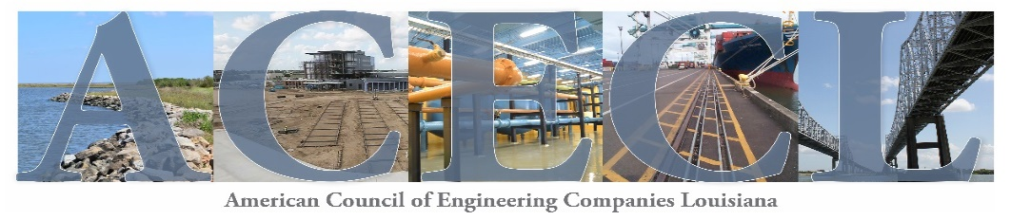
2026 Annual Sponsorship Opportunities
The American Council of Engineering Companies of Louisiana (ACECL) is the voice of Louisiana’s engineering industry. Founded in 1950, ACECL exists to protect, educate, and advance the business of consulting engineering.
ACECL consists of more than 150 engineering firms and affiliates, which employ over 8,000 highly-skilled professionals and support personnel whose creativity and technical powers result in several billion dollars in construction value each year.
Position your firm to get the most marketing bang for your buck with an ACEC of Louisiana Annual Sponsorship. These sponsorship opportunities will pay dividends throughout 2026 with company recognition at ACEC of Louisiana’s premiere events, as well as ACEC of Louisiana’s website and monthly newsletters.
ANNUAL SPONSORSHIP: $2,000

●Company logo on ACEC of Louisiana’s website homepage

●Company logo in ACECL’s monthly electronic newsletter
● Banner signage at ALL premier events, including Chapter meetings across the State

● 2 complimentary ACECL Chapter Luncheon vouchers

●1 complimentary 2026 ACECL Fall Conference Registration

PLATINUM ANNUAL SPONSORSHIP: $5,000
●Company logo on ACEC of Louisiana’s website homepage
●Company logo in ACECL’s monthly electronic newsletter

● Banner signage at ALL premier events, including Chapter meetings across the State

●2 complimentary ACECL Chapter Luncheon vouchers
● ACECL 2026 Fall Conference-Gold Sponsor (recognition on event promotional materials, signage & 1 complimentary registration)
●ACECL EEA Gala-Gold Sponsor (recognition on event promotional materials, signage & 2 complimentary tickets)
● Construction Industry Summit (formerly Critical Issues Summit) – CIS Supporting Sponsor (recognition on event promotional materials & signage)

Contact: Janet Landry at jlandry@acecl.org or call (225) 927-7704

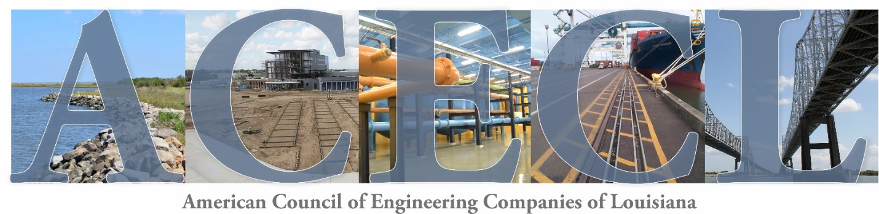
The American Council of Engineering Companies of Louisiana (ACECL) is offering an opportunity for your company to be in the spotlight in 2026! We are once again extending to member firms and affiliates cost-effective advertising opportunities. You can gain long-term exposure to all members and A/E/C partners by becoming a 2026 Annual Sponsor.
Firm: _____________________________________________________________________________________________________
Address: _________________________________________________________________________________________________
City: ______________________________________________ State: ________________________ Zip: _____________________
Contact Name: Email: ___________________________________

______Platinum Annual Sponsorship Cost - $5,000
______Annual Sponsorship Cost - $2,000
Please make checks payable to:
ACEC/Louisiana
and submit to:
ACEC/Louisiana
18212 E. Petroleum Dr., Bldg. 7 Baton Rouge, LA 70809

TO ENSURE YOUR COMPANY WILL BE PROPERLY REPRESENTED PAYMENT IS DUE 30 days upon receipt of invoice. Deadline to be included on banner signage is January 30, 2026.

Send your company logo to jlandry@acecl.org

FOR OFFICE USE LOGO REC’D:__________
CHECK NUMBER: ____________________

